This assembly guide provides guidelines to fabricate a 6 meter 3-element yagi. Tom McDermott –N5EG modeled it for optimized operation at 50.1 MHz and Dick Sander –K5QY constructed and tested it

The below Gain and Front-to-Back Curves show the design over a wide bandwidth..

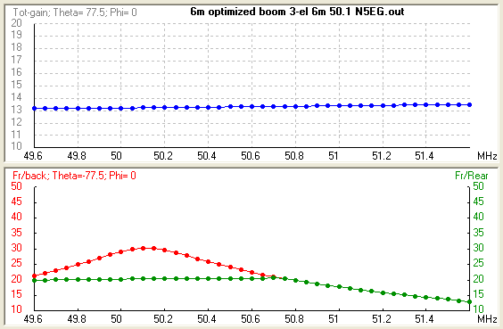

The following illustrations give guidelines to help with the antenna construction:
1) BOOM

6 Meter 3-element Yagi Construction
Boom- 1 in. X 6 ft square tubing
(Texas Tower or Grainger)
Side View:
Bottom View:
30.5 in.
41 in.
Center all holes in the middle

Note: Grid lock snaps lines to a square
Center all holes in the middle
Note: Grid lock snaps lines to a square
Drill three holes for ½ in. Dia. Elements (3 places)
Drill three 0.2 in. (#25) holes to secure the elements (3 places)
Prepare 6 ft Boom
2) ELEMENTS

½ in. X 48 in. Alum tubing
(3 each)
3/8 in. X Alum tubing.

(Add 2 in. on each end
to slide into the center)
30.5 in.
35 in.
41 in.
32.5 in.
29 5in.
118 in.
Total
113 in.
Total
105 in.
107 Total
Drill 0.164 in. (#29) hole
and tap 8-32 threads In the
center of each element

Note: I tapped the hole through
one side –if you wish you can
drill and tap the 8-32 hole
completely through the element
Prepare Each Element
Cut four ¾ in. slots at each
end
REF
DE
DIR

3) GAMMA MATCH

Gamma Match Rod Tube- 0.305 ID, 3/8 in. OD X 12 in. Tubing (Grainger PN 4NRY5)
Element-to-Gamma Rod attachment pieces- 2 each, ½ in. X 4 in. (I used thin aluminum from
a Bud chassis box, trim it using metal shears)
CL
1 ¼”
Drill four holes for 4-40 SS screw
(¼” from ends)
Use needle nose pliers and
bend just clear of the 4-40 holes
Loosely insert the four 4-40 SS screws. Use force to wrap the 1” X 4” plates and bend Into a bracket forming the element to the Gamma rod attachment
½”Driven Element
1 3/4”
3/8” Gamma Rod
4) CONNECTOR BRACKET

Prepare SO-239 Coax Connector Bracket- Use 1 in. X 4 in. aluminum
Inner Gamma Rod- 14 in. RG-213 with shield removed
1 3/4”
2 1/4”
1 3/4”
2 1/4”
CL
Cut out hole for SO-239
Chassis connector
1 3/4”
1/2”
Bend into “L”
1/2”
Solder SO-239 Chassis connector
to coax
RG-312 center conductor
5) SUBASSEMBLIES

Figure 1 shows assembly of the yagi after the boom, elements, and gamma match subassemblies have been fabricated.

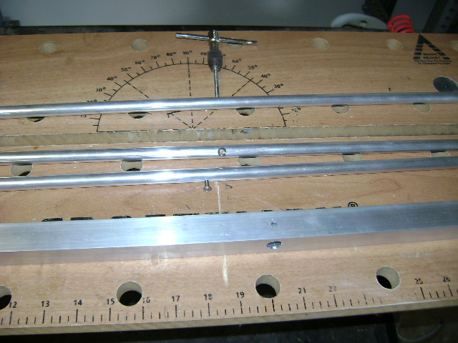
Figure 1. Yagi Assemblies

6) ELEMENT TO BOOM ASSEMBLY

Start by inserting each ½ in. X 48 in. element into the boom. Align the 8-32 threaded holes of the center element to the holes in the boom and tighten down a ½ in. 8-32 screw and lockwasher into the Reflector and Director elements.(Don’t insert a screw into the Driven element yet.) See Figure 2.

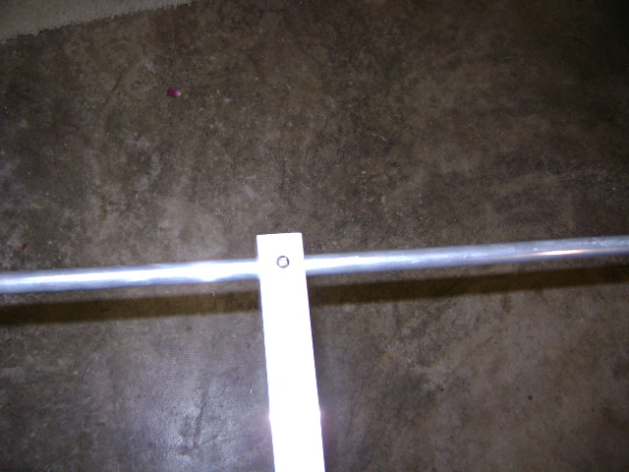
Figure 2. Center Elements into Boom Installation

7) GAMMA MATCH INSTALLATION

Install the L-bracket with connector and coax into the Driven element using an 8-32 screw and lockwasher. Note: Connector should face towards the center of the boom (or Director). Figure 3 shows the connect rear facing the Reflector.

Install the 3/8 in. X 12 in. gamma rod tubing over the coax.

Install the two assemblies supporting the Driven element to the gamma rod with 4-40 screws and lockwasher. (Do not completely tighten –just enough to secure the gamma assembly.)

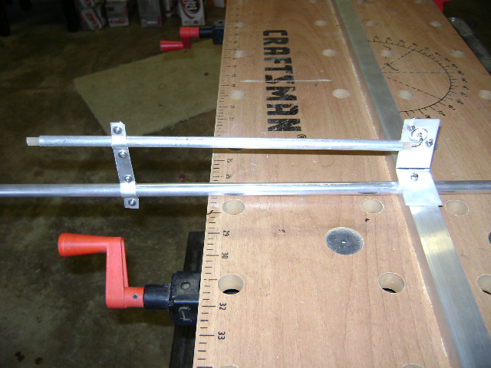
Figure 3. Gamma Match Installation

- 3/8 in. ELEMENT TIP INSTALLATION

Install the 3/8 in. element tips into the ½ in. elements. Loosely tighten each with SS #4 hose clamps.

Note: Each element should be at least 2 inches or longer to slide in the larger tubing.

Reflector (rear) 35 in. Total Reflector length 118 in.
Driven Element 32.5 in. Total Driven Element length 113 in.
Director (front) 29.5 in Total Direct length 107 in,

When all elements are measured, tighten the #4 hose clamps.

- ADJUST GAMMA MATCH

Note: A boom-to-mast mounting bracket was not built in this assembly guide. It is up to the user to fabricate his own.

Note: A ½ -wavelength length of coax reflects the actual yagi feed point impedance. If one is available it should be used.

Figure 4 shows the yagi 8 ft above ground while the gamma match is adjusted. If a mast is not available pointing the beam towards the sky with the Reflector element near ground will give acceptable results.

Connect SWR Analyzer.

Start by moving the 3/8 in. gamma back and forth until the lowest SWR is obtained. Then move the two plates between the Driven element and gamma rod until the lowest SWR is obtained.

Repeat above procedure until an acceptable low SWR is obtained and tighten the four
4-40 screws down. Weather proof the gamma match.

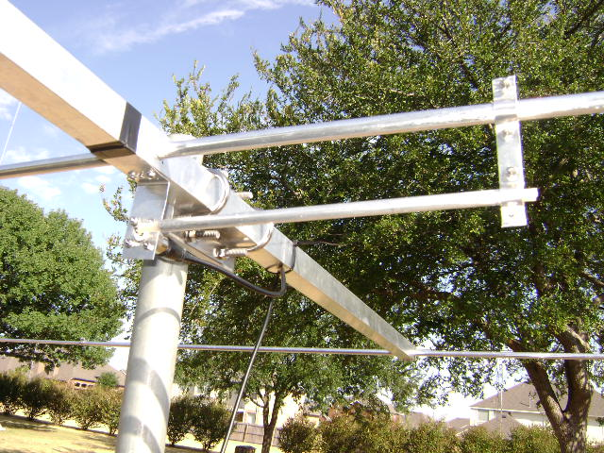

Tested at 50.1 MHz and A-B compared favorably to my 4-ele optimized yagi.

